**Guide: How to view the OurVoice Figma File**

Step 1: Upload the File to Figma Web

1. Open your web browser and go to the Figma website ([www.figma.com](http://www.figma.com/)).
2. If you already have a Figma account, log in. If not, create a free account by clicking "Sign Up" and following the registration process.
3. Once you are logged in, you should be on the Figma dashboard.
4. Click on the "import" button located at the top-right corner of the dashboard.

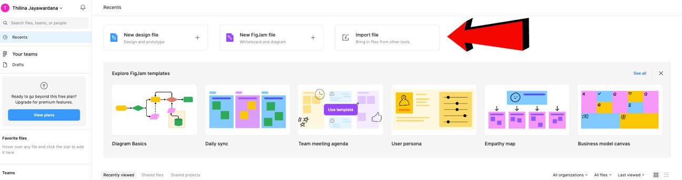

1. A file picker dialog will open. Navigate to the location where you have saved the "OurVoice.fig" file on your local desktop and select it.
2. The file will begin uploading to Figma.

Step 2: View the Figma File

1. After the file is uploaded, you'll be directed to the design editor in the Figma web application.
2. In the Dashboard “**Drafts”** section will show your "OurVoice.fig" design, and you can view and interact with it as you would with any Figma design.

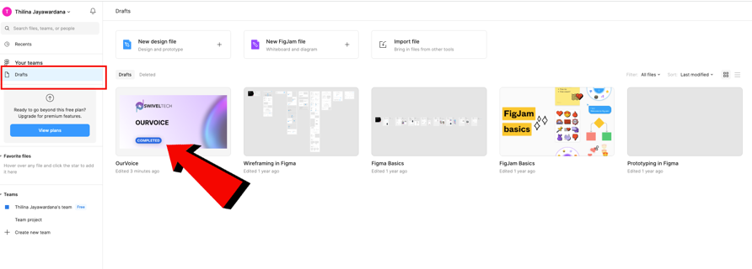

1. Use the toolbar and navigation options to explore the design, zoom in and out, and interact with the different elements.

More References

Figma Learn : [Import files into Figma](https://help.figma.com/hc/en-us/articles/360041003114-Import-files-into-Figma#:~:text=the%20file%20browser.-,Import%20files%20via%20drag%20and%20drop,file%20browser%20or%20the%20Editor.)

<https://help.figma.com/hc/en-us/articles/360041003114-Import-files-into-Figma#:~:text=the%20file%20browser.-,Import%20files%20via%20drag%20and%20drop,file%20browser%20or%20the%20Editor>.

Video Tutorial: [How To Import Fig File To Figma](https://www.youtube.com/watch?v=fATVMo1nCZ0&ab_channel=RaoufBelakhdar)  
<https://www.youtube.com/watch?v=fATVMo1nCZ0&ab_channel=RaoufBelakhdar>